# **Venkata Gopinath Ginjupalli**

Business Analytics and Information System

**Final Project Report**

Comprehensive Assessment of the Global Economy

**Data Visualization**

Prof. Johannes Reichgelt, PhD

# **Introduction:**

Over the last few years, the global economy has been subjected to significant changes and problems, including the ongoing COVID-19 epidemic, political instability, and changes in the global economic environment. Furthermore, the global economy has been subjected to significant changes and challenges in recent years. Economic data that is both credible and up to date is required for lawmakers, investors, and analysts to grasp these trends and make educated decisions. The World Bank is often considered as one of the most credible sources of economic statistics since it gathers a significant quantity of information on a wide range of economic indicators from nations all around the world. Because the World Bank collects data from countries all over the world, this is the case.

In this inquiry, we will focus on two datasets accessible on the World Bank website: Prices and Exchange Rates in the Economy and Economy Size in Worldview. Both of these are accessible via the "Economy" tab. These datasets encompass a wide range of economic indicators and provide an in-depth examination of the various aspects that influence an economy's development and progression. The official exchange rate, purchasing power parity, price level ratios, and real effective exchange rates are only a handful of the indicators in the dataset titled "Economy: Exchange Rates and Prices." These metrics, together with a country's trading relationships with other countries and inflation rates, are critical for determining a country's overall level of economic success.

In a word, the fundamental purpose of this study is to provide a complete assessment of global economics, with a specific emphasis on the datasets chosen, and to provide answers to two key research questions. Furthermore, the goal of this research is to provide a comprehensive examination of the global economy. Our objective is to give a more in-depth knowledge of the global economy's performance, the likely causes of economic activity, and how different economic indicators interact with one another. We have high hopes that our research will contribute to a better understanding of the patterns that have been affecting the global economy, as well as provide policymakers, analysts, and investors with useful information.

**The purpose of this project is to provide answers to the following two main research questions:**

What effects, if any, do pricing, exchange rates, and purchasing power parity have on a country's economic growth and development? The Exchange Rates and Prices dataset includes indicators such as the DEC conversion factor for converting local currency units to US dollars, the Official exchange rate for converting local currency units to US dollars, the Purchasing power parity for converting local currency units to international dollars, the Price level ratio of the PP Index (US = 1.00), the Real effective exchange rate Index (2010 = 100), annual percentage changes in consumer prices, and annual percentage changes in consumer prices. These metrics give information on the influence of a country's exchange rates, prices, and purchasing power parity on the growth and development of its economy.

What characteristics of a country's population, land area, population density, gross national income, gross national income per capita, purchasing power parity, gross national income, and gross domestic product growth rate are the most important indicators of the country's economic expansion and development? The population, surface area, population density, gross national income, gross national income per capita, and gross domestic product growth rate of a country may give insight into these parameters. Population (millions), Surface area (sq. km thousands), Population density (people per sq. km), Gross national income, Atlas method ($ billions), Gross national income per capita, Atlas method ($), Purchasing power parity gross national income ($ billions), and Gross domestic product (% growth) are all included in the "Size of Economy" data set. These indicators provide a comprehensive view of a country's economy and its pace of growth.

The goal of this study is to contribute to a better understanding of the variables that contribute to and are determined by economic growth and development across nations by addressing these research areas. In addition, the paper attempts to provide insights that, by being presented, will hopefully have an impact on governmental choices and development plans.

# **Methodology:**

Tableau, a powerful data visualisation and business intelligence tool, will be the primary tool we use to analyse the selected datasets and deliver answers to the study questions. Tableau will be used to create interactive dashboards and visualisations to help us obtain insights into the data and answer the research questions.

## **Sources of Information:**

Our data will come from the World Bank, which has a large database of economic statistics gathered from countries all around the world. Economy: Exchange Rates and Prices and WorldView: Economic Size are two datasets available on the World Bank website (http://wdi.worldbank.org/table). Both of these datasets will be used. These data include a wide range of economic indicators, such as exchange rates, prices, population, gross national income, and gross domestic product.

Getting the Data Ready We will need to clean and preprocess the data before importing it into Tableau to ensure that it is correct and complete. To ensure that the data is consistent and easy to work with, we will do data cleaning procedures such as eliminating duplicates, filling in missing values, and standardising variable names. These steps will be taken to make sure the data is easy to work with. Furthermore, we will modify the data to make it more suitable for analysis. This might include, for example, calculating additional variables or categorising the data.

Data Interpretation After we have prepared the data, we will import it into Tableau and create exploratory dashboards and visualisations to answer the research objectives. We will use a variety of data visualisation approaches, including scatter plots, bar charts, and line graphs, to acquire a clear image of the links between the numerous variables that comprise the datasets. In addition, we will create geographical visualisations and maps to better comprehend the global distribution of key economic indicators.

# **Analysis:**

Tableau provides us with a number of different visualisations that we can use to answer the first research question. We are able to generate a line chart to investigate the pattern of chosen nations' real effective exchange rates, official exchange rates, and the trend of exchange rates. A scatter plot may also be made to compare the purchasing power parity of local currency units to international dollars as well as the GDP deflator yearly percentage change for a variety of nations.

Tableau provides us with a number of different visualisations that we can use to help answer the second research question. We are able to illustrate the population density of the various nations with the use of a map. The gross national income, the gross national income adjusted for purchasing power parity, and the gross national income per capita of various nations may also be compared using a stacked bar chart that we can generate. In addition, we may examine the rate of increase in gross domestic product (GDP) of certain nations over a given time period by using a line chart.

We can discover how factors such as exchange rates, prices, and purchasing power parity influence the expansion and development of a nation's economy by examining the charts and graphs presented here. We are also able to identify the primary factors that contribute to the expansion and development of a nation's economy, such as its population, surface area, population density, gross national income, gross national income per capita, gross national income adjusted for purchasing power parity, and gross domestic product growth rate.

# **Visuals:**

The tableau visual story is made up of five individual sheets, each of which displays its own unique piece of information on the global economy. The first page features a globe map as well as a population map that shows the total number of people living in each country in 2021. The second sheet shows a filtered image of the world that highlights the top ten most populated countries based on the set of country names. The third sheet examines inflation and purchasing power parity, displaying the trend of consumer price inflation as well as the change in the purchasing power parity index over time. In addition to official exchange rates, the fourth sheet shows trends of GDP growth and actual exchange rates. This sheet focuses on GDP and currency rates. The price level and the gross national income are compared on the very last page.

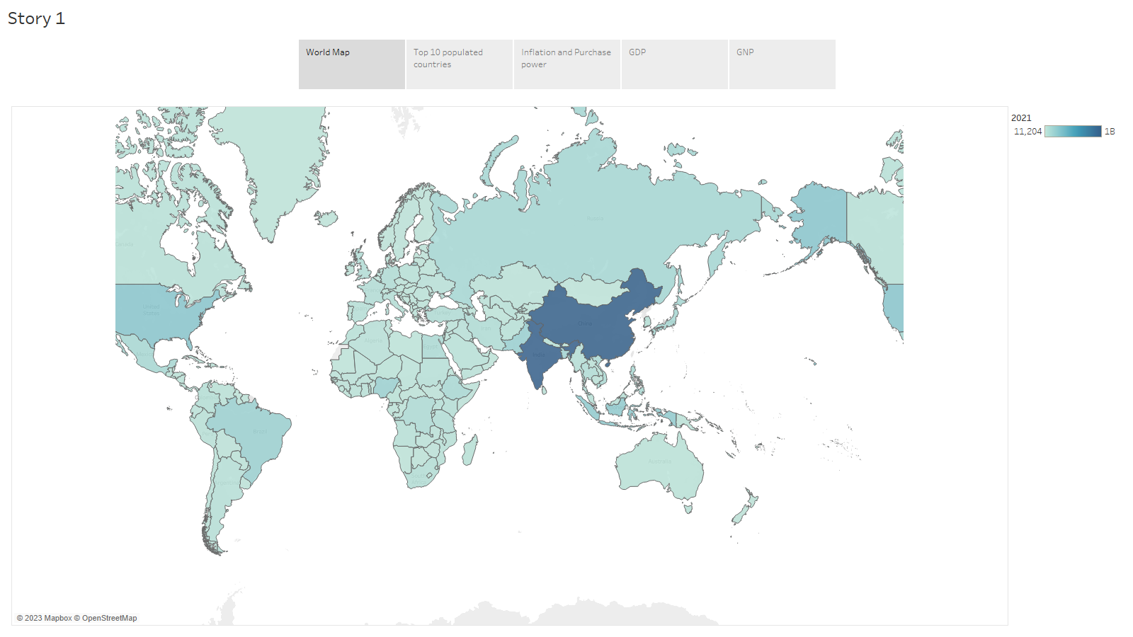

Sheet:1 includes a world map and a population map. The population map depicts the total number of people living in each country in 2021. According to the facts given, China has the most population on earth, followed by India. Both North America and Europe have a high population density.

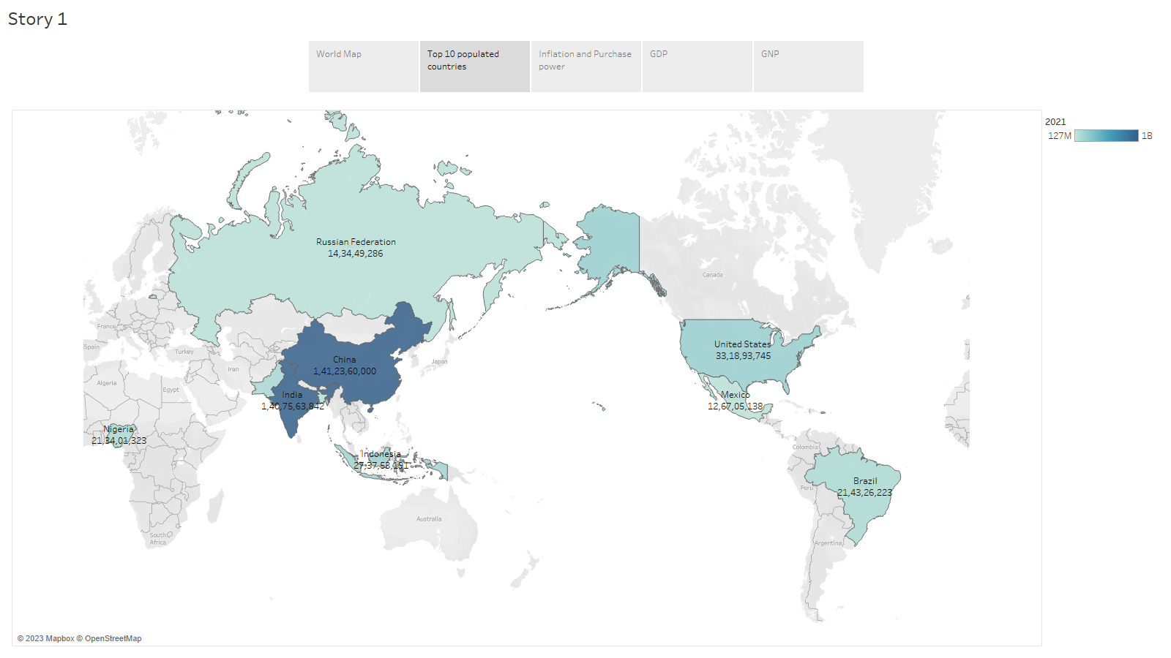

Sheet:2 depicts the top ten most populated nations on the planet, sorted by the countries contained in the list of country names.

The picture is useful in identifying which countries have the most population. This filtering is done because observing each country for some metrics might leave the viewer bewildered due to additional information floating in the graphics.

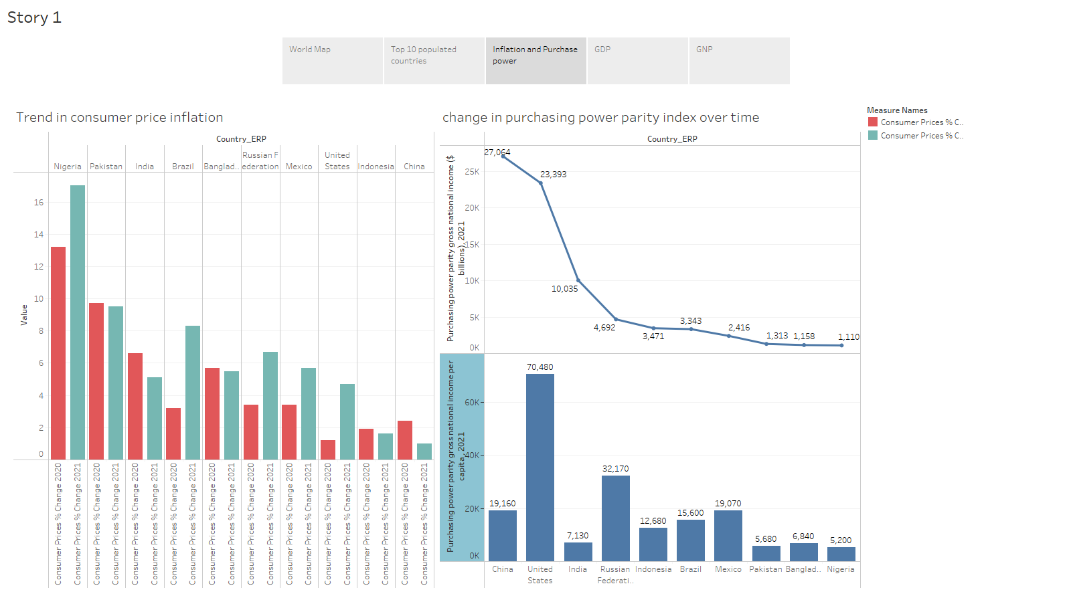

Sheet:3 discusses the subjects of inflation and purchasing power parity. The line chart depicts the evolution of consumer price inflation as well as the change in the purchasing power parity index over time. The visual tool aids in evaluating which countries today have the highest and lowest inflation rates. Nigeria had the highest annual inflation rate of 13% in 2020, which climbed to 17% the following year. In a number of nations, notably China and India, the inflation rate in 2021 is predicted to be lower than in 2020. China has the greatest purchasing power parity (PPP) in the world. With a per capita PPP of more than $70,000, the United States of America is second only to China in the worldwide PPP rankings.

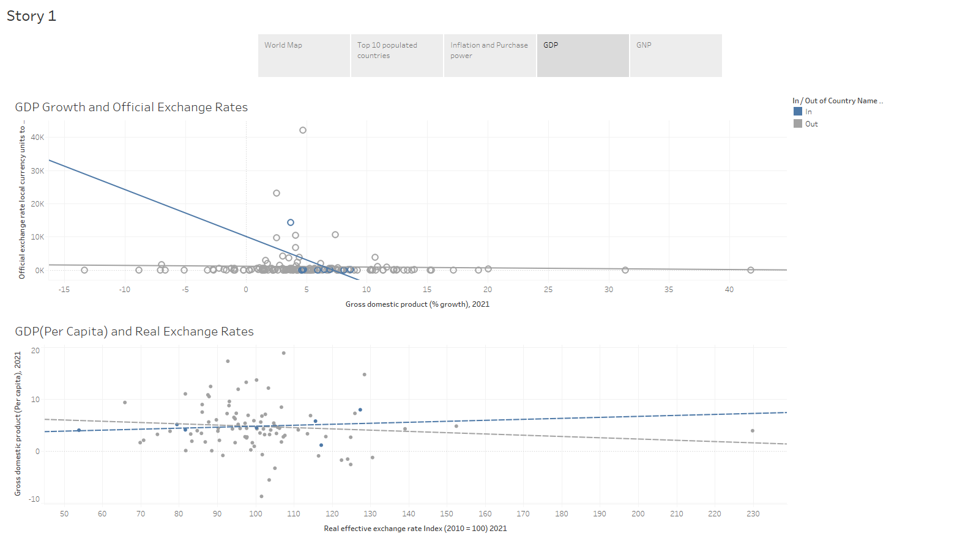

Sheet:4 contains data on the Gross Domestic Product (GDP) and various currency rates. The graph depicts the evolution of real exchange rates, GDP growth, and population density. The visual aid is useful in assessing which countries have the highest and lowest GDP growth rates, as well as the link between GDP and population density. It has been observed that the top countries are heading in a separate direction in comparison to the rest of the world. When we compare the GDP and real exchange rates for 2021, we see that while the GDP is increasing, the exchange rate is also rising. However, this is not the case for the rest of the world, as evidenced by the graph, which shows the opposite. In terms of population density, the top nations have an inclination that is positively inclined but not nearly as steep as previously. That is, in comparison to the top ten nations, the rest of the world's GDP grows faster when population density increases.

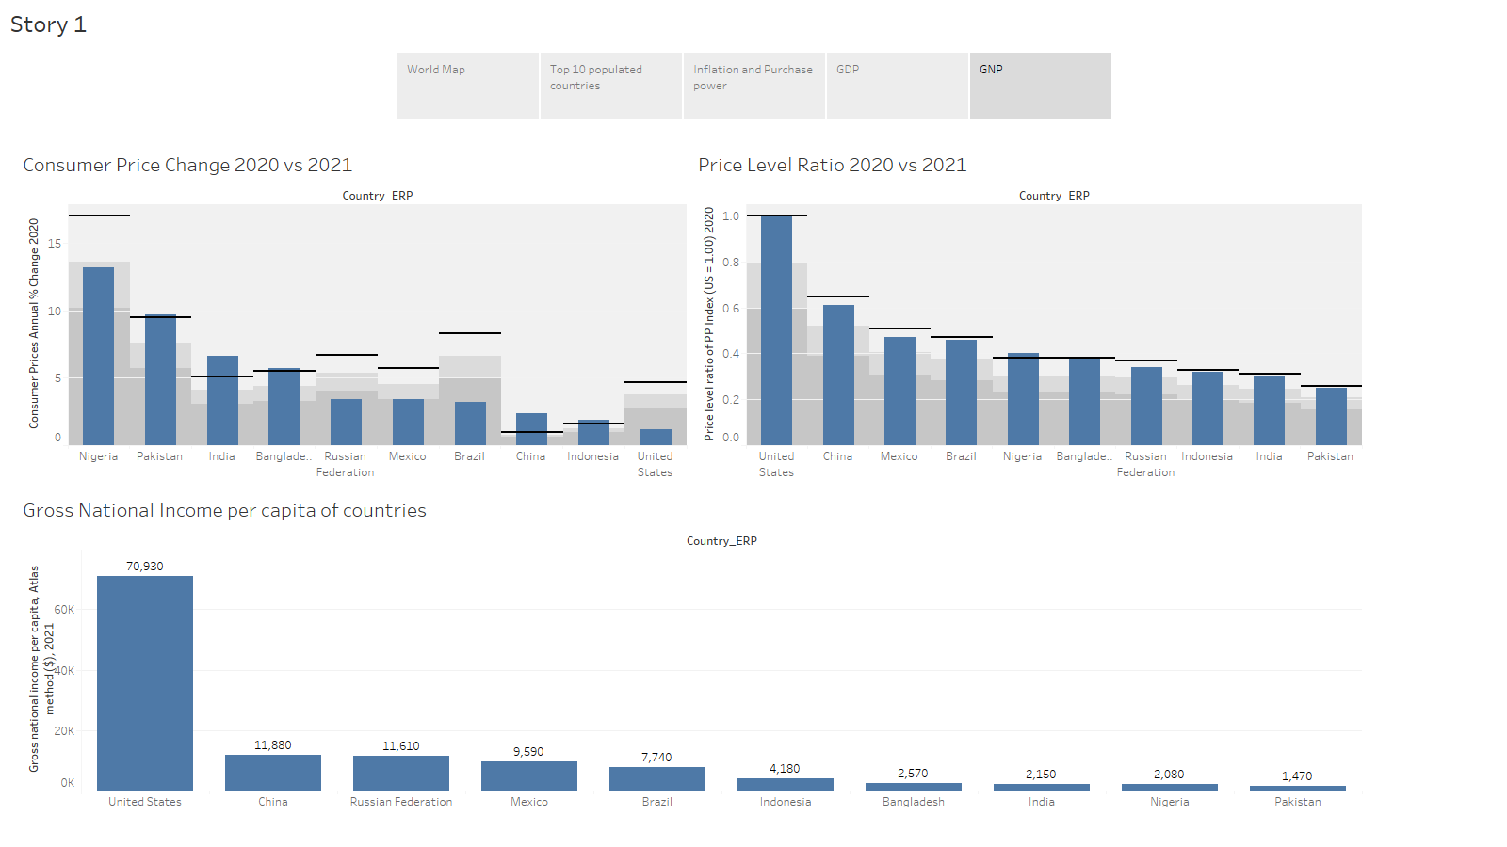

The ratios of gross national income to the total price level are shown on sheet:5. The visual aid is useful in establishing which countries have the highest and lowest levels of GDP per capita, as well as price level ratios. The image may be useful in assessing which potential markets provide opportunities for developing a business or making investments. The figures provided here show that the United States' gross national product (GNP) is much larger than that of other countries, with a nearly seven-fold difference. Using the United States as a benchmark, each of the top nine nations' price level ratio has grown compared to the previous year, with the exception of Nigeria, where it has slightly decreased, and Bangladesh, where it is unchanged from the previous year. Consumer price changes have moderated in a number of nations, including Pakistan, India, Bangladesh, China, and Indonesia. Price fluctuations in these nations have ranged from high to low. Nigeria, Russia, Mexico, Brazil, and the United States, on the other hand, had considerable percentage changes from the previous year. The United States of America and Brazil had the greatest percentage increases, while India and China experienced the greatest percentage decreases.

In conclusion, the tableau visual tale presents an overview of the global economy by highlighting various nations' populations, inflation rates, gross national incomes, exchange rates, and price level ratios.

# **Conclusion:**

Finally, this research sought to give a thorough evaluation of the global economy through the use of two World Bank datasets: Economy: Exchange Rates and Prices and Worldview: Economic Size. The study tried to answer two fundamental research questions: the impacts of pricing, exchange rates, and purchasing power parity on a country's economic growth and development, as well as the most essential economic expansion and development indicators.

To answer these research questions, we analysed the information and provided insights using Tableau, a sophisticated data visualisation and business intelligence tool. Data cleaning processes were carried out to guarantee consistency, completeness, and analytical appropriateness. Then, using various data visualisation techniques, exploratory dashboards and visualisations were created to gain a better understanding of the relationships between the variables.

The study's findings underscored the importance of pricing, exchange rates, and purchasing power parity in a country's economic growth and development. In addition, we highlighted crucial indices of economic expansion and development, such as the GDP growth rate, GDP per capita, and population density.

Some potential future research questions that could build upon this study and expand our understanding of the global economy are: How do political and social factors impact a country's economic growth and development, in addition to the economic indicators explored in this study? What is the impact of technological innovation on the global economy, and how can countries harness technology to drive economic growth and development? How does international trade affect the economic growth and development of different countries, and what policies can be implemented to promote fair and sustainable trade practices? How does climate change and environmental degradation impact the global economy, and what steps can be taken to promote sustainable economic growth and development?

Overall, this study helps policymakers, analysts, and investors comprehend the global economy and provides essential information. The findings of this study can help countries make educated decisions to enhance economic growth and development.